**WELCOME TO CQ REAL ESTATE**

**HOME PAGE**

**ABOUT US**

**CONTACT US**

**SIGN IN**

**SIGN UP**

**OFFERS**

**PRODUCTS**

Email address

**Sign in**

Password

**CQ REAL ESTATE**

**SIGN IN**

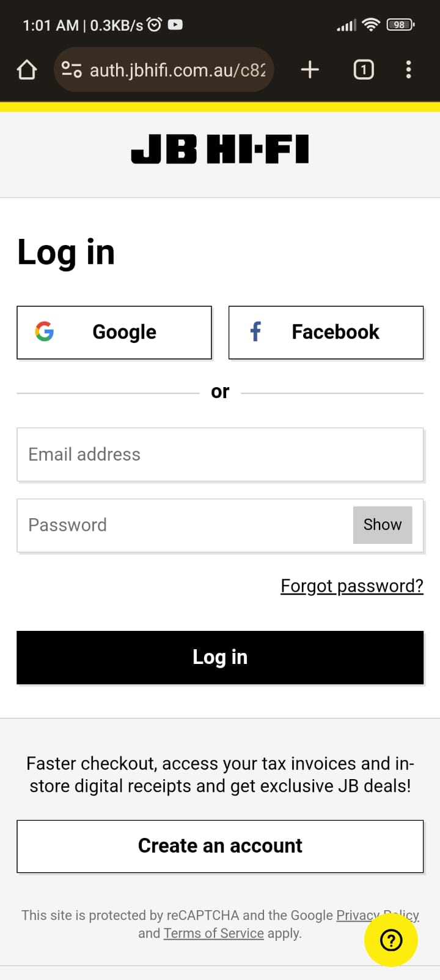

**OR**

Forgot password?

vv

**CQ REAL ESTATE**

   

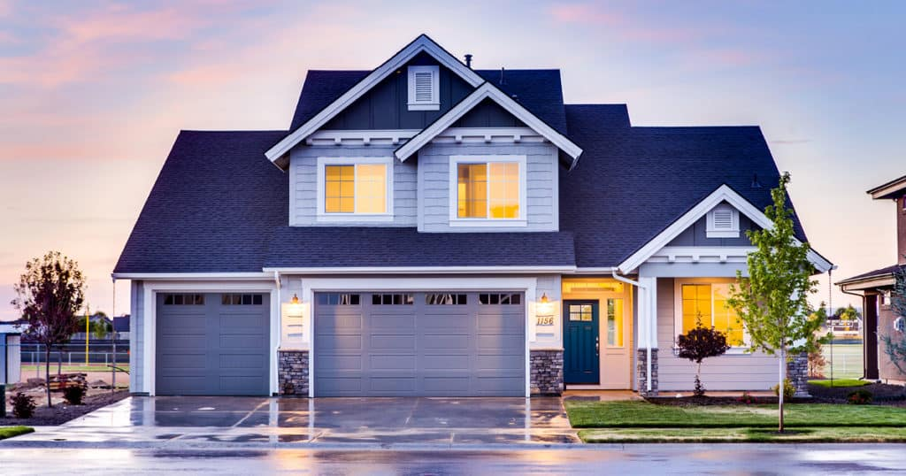

















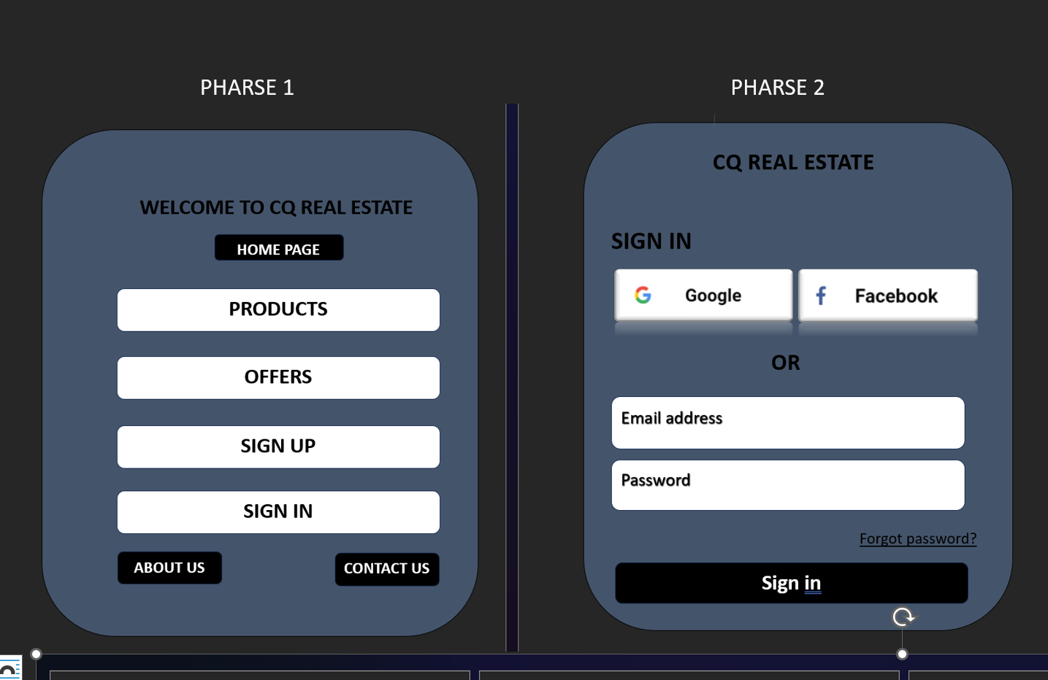

Design 4

**CQ REAL ESTATE**

**SIGN IN**



**OR**

Forgot password?